Indexer:

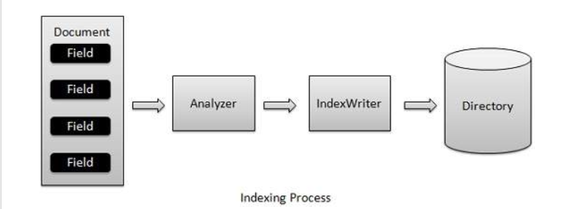
org.apache.lucene.index:
Code to maintain and access indices.
- IndexWriter: IndexWriter which creates and adds documents to indices.
- writer.updateDocument: This operation is used to update indexes to reflect the changes in the updated contents. It is similar to recreating the index.
org.apache.lucene.analysis.en.EnglishAnalyzer: An Analyzer builds TokenStreams, which analyze text. It thus represents a policy for extracting index terms from text.
import org.apache.lucene.document:
- org.apache.lucene.document.Document:
Documents are the unit of indexing and search. A Document is a set of fields.
- org.apache.lucene.document.Field
  - org.apache.lucene.document.TextField: Field options specify a way or control the ways in which the contents of a field are to be made searchable.
jsoup 1.6.0: jsoup is a Java library for working with real-world HTML.

Searcher:
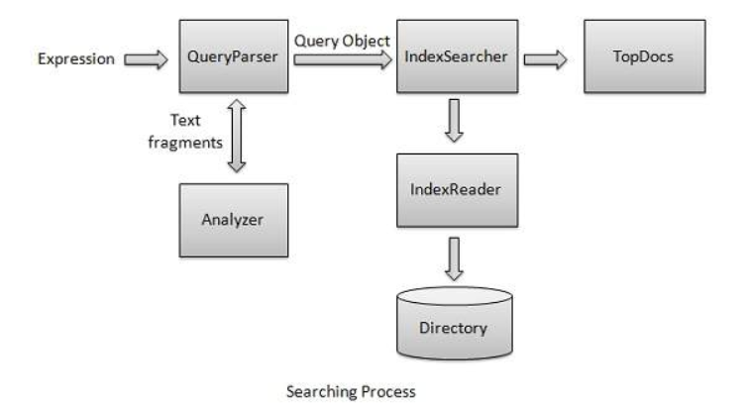
org.apache.lucene.queryparser.classic.QueryParser: A query parser, simply put, translates your search string into specific instructions for the search engine.
org.apache.lucene.search.IndexSearcher: Applications usually need only call the inherited search(Query,int) method. This class act as a core component which reads/searches indexes created after the indexing process. It takes directory instance pointing to the location containing the indexes.
org.apache.lucene.search.Query: The abstract base class for queries.
org.apache.lucene.search.ScoreDoc: Holds one hit in TopDocs.
org.apache.lucene.search.TopDocs: Represents hits returned by IndexSearcher.search(Query,int).
org.apache.lucene.search.similarities.ClassicSimilarity:
public class ClassicSimilarity extends TFIDFSimilarity
org.apache.lucene.search.similarities.BM25Similarity:
public class BM25Similarity extends Similarity

USER GUIDE:

Execute the following command:
java -jar [Program_name].jar [path_of_data_dir] [path_to_store_indexes] [Query] [VS/OK]

For example:
C:\Users\Pawan Joshi\Desktop\Ir programming>java -jar IR_P.jar "C:\Users\Pawan Joshi\Desktop\Ir programming\Data" "C:\Users\Pawan Joshi\Desktop\Ir programming\Index" "sunny berlin?" "ok"

Note: Default value for VS/OK is VS

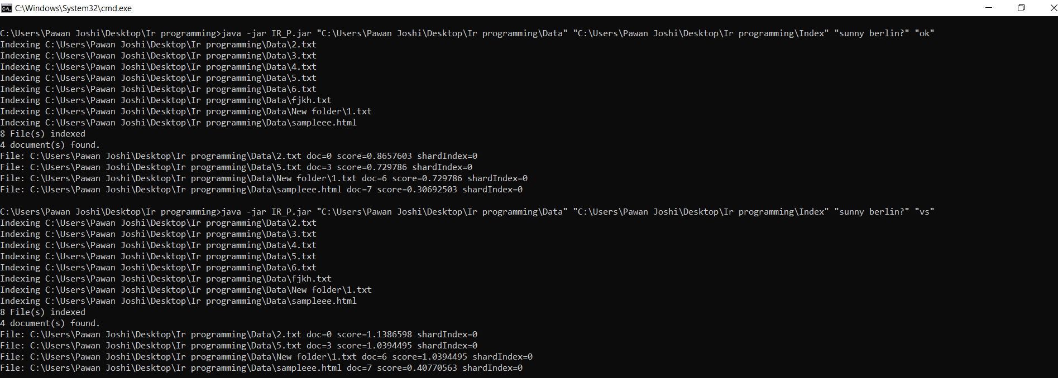

References:
1) https://lucene.apache.org/core/7_5_0/index.html
2) https://www.tutorialspoint.com/lucene

